RESTFUL API
What is REST?
Whenever a Client makes a request to the Server, it uses the HTTP Request.
HTTP Request is basically the language you are using to make the request. But it is not the only “language” the servers can speak. Other languages are: FTP (File Transfer Protocol) Request, HTTPS Request, etc. If you use the wrong language, you might not get back the resources you requested.
Example:
app.get(function(req, res) {…});

REpresentational State Transfer or REST is an architectural style for designing APIs. It is also not the only style for APIs. Other popular styles are SOAP, GraphQL, Falcor, etc.
REST proposes a set of rules web developers can follow when building APIs.

2 Important REST API Rules to follow:
- Use HTTP Request Verbs
HTTP Methods | CRUD Functions
GET | READ  Example: app.get(function(req, res) { … } );
POST | CREATE  Example: app.post(function(req, res) { … } );
PUT | UPDATE  Example: app.patch(function(req, res) { … } );  PUT : Updating your DB by sending an entirely new entry to replace the previous one.  PATCH : Updating you DB by sending the only piece of data that needs to be updated.
PATCH
DELETE | DELETE  Example: app.delete(function(req, res) { … } );

- Use Specific Pattern of Routes/Endpoints URLs
HTTP Verbs | /articles | /articles/angela
GET | Fetches all the articles | Fetches the article on Angela
POST | Creates one new article | -
PUT | - | Updates the article on Angela
PATCH | - | Updates the article on Angela
DELETE | Deletes all the articles | Deletes the article on Angela

Create Data for the Database using Robo3T
Link: https://robomongo.org/
Robo3T, used to be called Robo Mongo, is a GUI that is commonly used with MongoDB.
- Run your Mongod server in the background.
(In your Hyper Terminal)
$ mongod
If your Mongod server is not running, your MongoDB connection using Robo3T will have a connection error.
- Create a new MongoDB connection using Robo3T and Save.
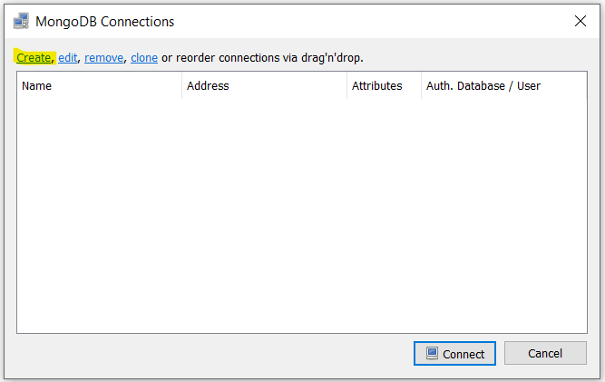
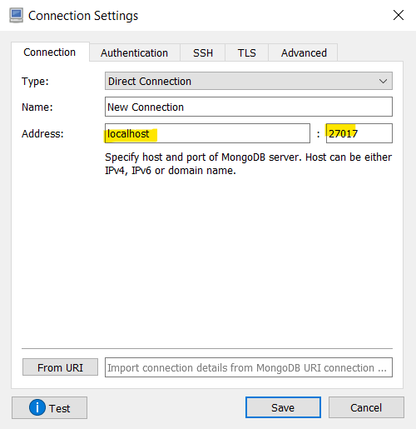
As you can see the default connection is using the localhost port 27017 which is MongoDB’s location in our local system. (MongoDB://localhost:27017/<database name>)
- Connect to your new MongoDB connection.
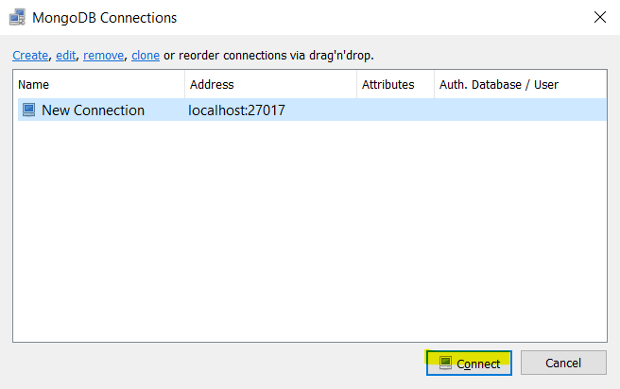

Using Postman
- Specify the HTTP Method you want Postman to send.
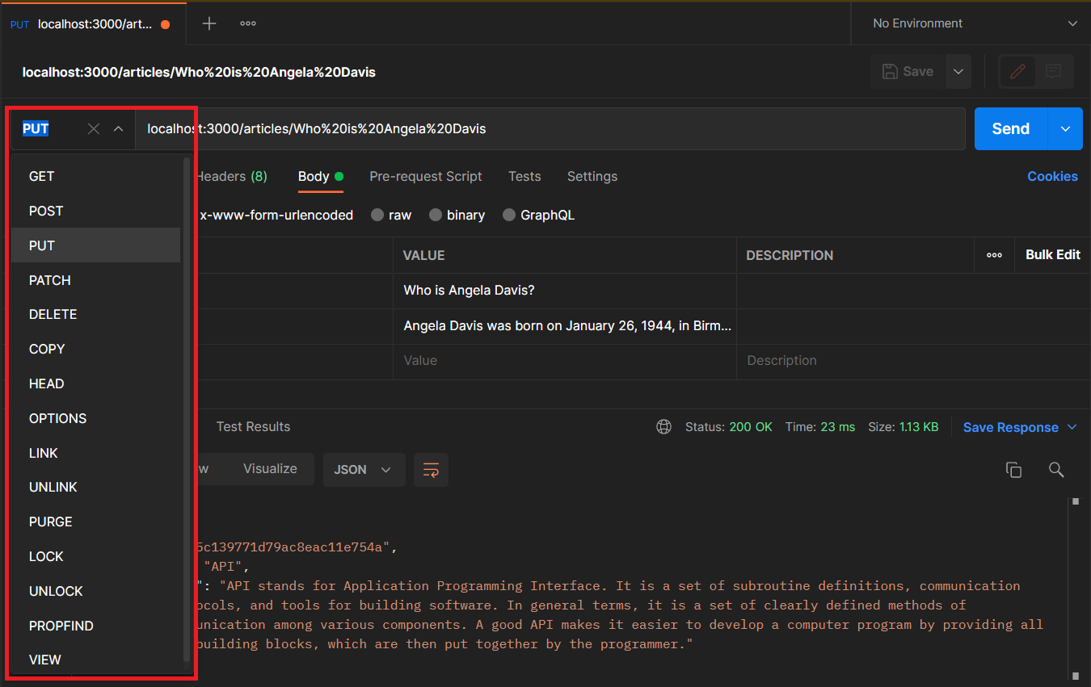
- Add the corresponding parameters to the URL box to specify the address in which the HTTP Method will be sent to.
- Add whatever data you need to send with the URL.
For form/body data: Select Body > x-www-form-urlencoded (since body-parser is designed to handle these) and specify the value you want to post.
- Click on the Send button.
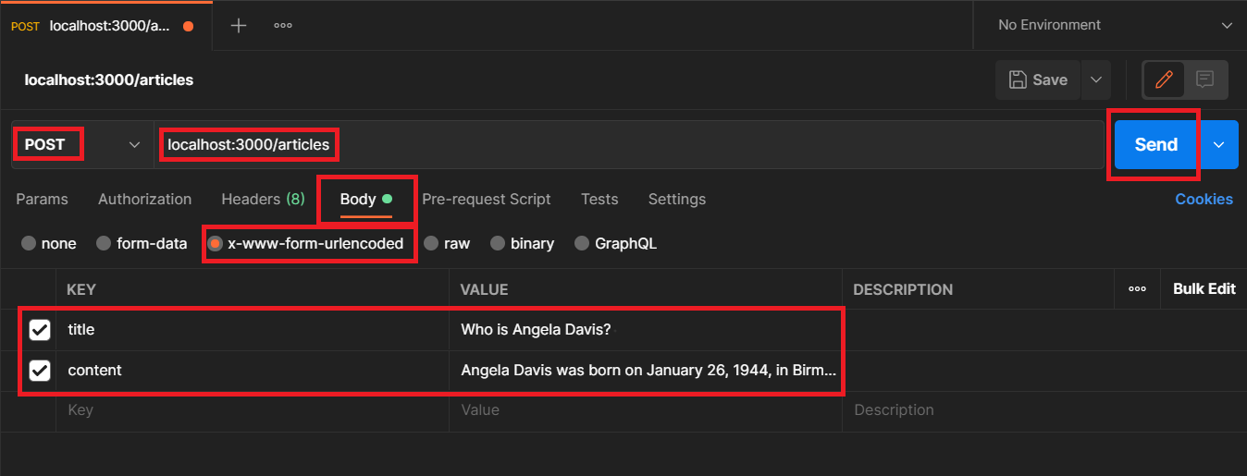

HTTP: PUT METHOD
Link: https://mongoosejs.com/docs/deprecations.html
PUT is a method of modifying resource where the client sends data that updates the entire resource. It is used to set an entity’s information completely. PUT is similar to POST in that it can create resources, but it does so when there is a defined URI. PUT overwrites the entire entity if it already exists, and creates a new resource if it doesn’t exist.
For example, when you want to change the first name of a person in a database, you need to send the entire resource when making a PUT request.
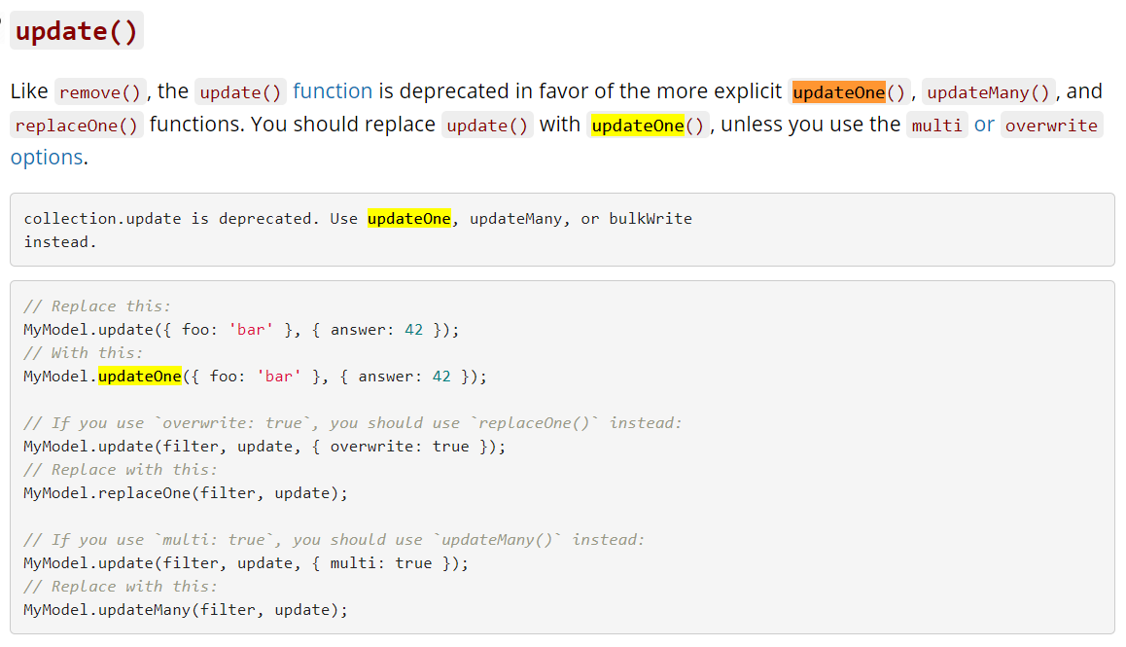
.put((req, res)=>{
const title = req.params.articleTitle;
Article.updateOne(
{title: title},
{title: req.body.title, content: req.body.content},
(err)=>{…}
)
}
Updating the Article collection using $set which does not overwrite the entire document but only updates the specific attribute of the document/record.
.put((req, res)=>{
const title = req.params.articleTitle;
Article.replaceOne(
{title: title},
{title: req.body.title, content: req.body.content},
{overwrite: true},
(err)=>{…}
)
}
overwrite: true causes the entire document to be replaced with whatever is specified in the 2nd parameter. If not all fields were specified for update, then that field with no values will be omitted when updating the document.
Put request will then interpret “missing” fields as the user wanting that field to be null or nill or non-existent.

HTTP: Patch Method
PATCH is used when you want to apply a partial update to the resource.
.patch((req, res)=>{
const title = req.params.articleTitle;
Article.updateOne(
{title: title},
{$set: req.body},
(err)=>{. . . }
);
}
{$set: req.body} this is a new way of setting your data’s key values that automatically matches with your collection’s field name
Conventional Way:
{
$set: {
title: req.body.title,
content: req.body.content
}
}

Another Way:
{ $set: req.body }

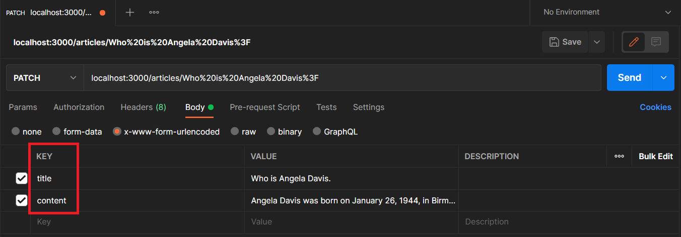
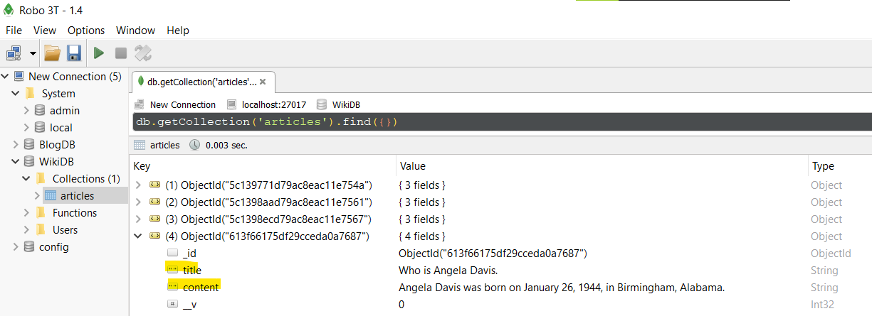

Complete Source Code:
- const express = require("express");
- const bodyParser = require("body-parser");
- const mongoose = require("mongoose");
- const ejs = require("ejs");
- const _ = require("lodash");

- const app = express();
- app.set("view engine", "ejs");
- app.use(bodyParser.urlencoded({
- extended: true
- }));
- app.use(express.static("public"));

- //Connecting to MONGOOSE
- mongoose.connect("mongodb://localhost:27017/WikiDB");

- const articleSchema = new mongoose.Schema({
- title: String,
- content: String
- });
- const Article = mongoose.model("article", articleSchema);

- // Using Chainable Route Handlers for REST.
- // every http request (get, post, delete, etc) are preceded by a dot (.) to indicate a chain method.
- // no semicolon at the end yet since we don't want the chain method to end yet.
- app.route("/articles")
- .get((req, res) => {
- Article.find({}, (err, result) => {
- if (err) {
- console.log("[ERROR][GET][/ARTICLES] ", err);
- } else {
- console.log("[INF][GET][/ARTICLES] ", result);
- res.send(result);
- }
- });
- })

- .post((req, res) => {
- const postTitle = req.body.title;
- const postContent = req.body.content;
- console.log("Post Title: ", postTitle);
- console.log("Post Content: ", postContent);

- const newArticle = new Article({
- title: postTitle,
- content: postContent
- });

- newArticle.save((err) => {
- if (err) {
- console.log("[ERROR][POST][/ARTICLES] ", err);
- res.send(err);
- } else {
- console.log("[INF][POST][/ARTICLES] ", newArticle);
- res.redirect("/articles");
- }
- });
- })

- .delete((req, res) => {
- Article.deleteMany({}, (err) => {
- if (err) {
- console.log("[ERROR][DEL][/ARTICLES] ", err);
- res.send(err);
- } else {
- console.log("[INF][DEL][/ARTICLES] Deleted Article Collection.");
- res.redirect("/articles");
- }
- });
- });

- // If your article title is more than one word with spaces and symbols other than the alphabet, it is better to search using a URL encoder/decoder.
- app.route("/articles/:articleTitle")
- .get((req, res) => {
- const title = req.params.articleTitle;
- console.log("Title: ", title);

- Article.findOne({
- title: title
- }, (err, result) => {
- if (err) {
- console.log("[ERROR][GET][/ARTICLES/", title, "] ", err);
- } else {
- console.log("[INF][GET][/ARTICLES/", title, "] ", result);
- res.send(result);
- }
- })
- })

- .put((req, res) => {
- const title = req.params.articleTitle;
- Article.replaceOne({
- title: title
- }, {
- title: req.body.title,
- content: req.body.content
- }, {
- overwrite: true
- },
- (err) => {
- if (err) {
- console.log("[ERROR][PUT][/ARTICLES/", title, "] ", err);
- } else {
- console.log("[INF][PUT][/ARTICLES/", title, "] Successfully updated entire resource.");
- res.redirect("/articles");
- }
- }
- )
- })

- .patch((req, res) => {
- const title = req.params.articleTitle;
- Article.updateOne({
- title: title
- }, {
- $set: req.body
- },
- (err) => {
- if (err) {
- console.log("[ERROR][PATCH][/ARTICLES/", title, "] ", err);
- } else {
- console.log("[INF][PATCH][/ARTICLES/", title, "] Successfully updated field.");
- res.redirect("/articles");
- }
- }
- );
- })

- .delete((req, res) => {
- const title = req.params.articleTitle;
- Article.deleteOne({
- title: title
- },
- (err) => {
- if (err) {
- console.log("[ERROR][DELETE][/ARTICLES/", title, "] ", err);
- } else {
- console.log("[INF][DELETE][/ARTICLES/", title, "] Successfully deleted article.");
- res.redirect("/articles");
- }
- }
- );
- });

- app.listen("3000", () => {
- console.log("Listening to Port 3000");
- });

